PROGRAMMING WITH PYTHON

CLASS PROJECT—7

PROGRAM—1

#photo shoot
import os

def takesnap():
os.system("fswebcam -F 4 --fps 20-r 800*600 /home/cl213/HarshithaGowda/temp.jpg")
print("image take")
return
takesnap()

OUTPUT
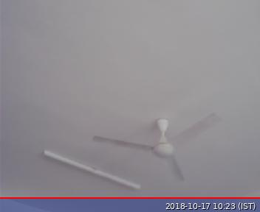

PROGRAM—2

#Libraries
import RPi.GPIO as GPIO
import time

#GPIO Mode (BOARD / BCM)
GPIO.setmode(GPIO.BCM)

#set GPIO Pins
GPIO_TRIGGER = 18
GPIO_ECHO = 24

#set GPIO direction (IN / OUT) HARSHITHA
GPIO.setup(GPIO_TRIGGER, GPIO.OUT)
GPIO.setup(GPIO_ECHO, GPIO.IN)

def distance():
# set Trigger to HIGH
GPIO.output(GPIO_TRIGGER, True)

# set Trigger after 0.01ms to LOW
time.sleep(0.00001)
GPIO.output(GPIO_TRIGGER, False)

StartTime = time.time()
StopTime = time.time()

# save StartTime

while GPIO.input(GPIO_ECHO) == 0:
StartTime = time.time()

# save time of arrival
while GPIO.input(GPIO_ECHO) == 1:
StopTime = time.time()

# time difference between start and arrival
TimeElapsed = StopTime - StartTime
# multiply with the sonic speed (34300 cm/s)
# and divide by 2, because there and back
distance = (TimeElapsed * 34300) / 2

return distance

if __name__ == '__main__':
try:
while True:
dist = distance()
print ("Measured Distance = %.1f cm" % dist)
time.sleep(1)
if (dist>100):
print("distance is above 100")
break

# Reset by pressing CTRL + C
except KeyboardInterrupt:
print("Measurement of distance has been stopped by User")
GPIO.cleanup() HARSHITHA

OUTPUT:

Measured distance = 4.8 cm
Measured distance = 5.4 cm
Measured distance = 5.8 cm
Measured distance = 4.0 cm
Measured distance = 5.6 cm
Measured distance = 6.3 cm
Measured distance = 9.5 cm
Measured distance = 5.2 cm
Measured distance = 3485 cm
distance is above 100.

HARSHITHA
CL-2
ECE=C-SECTION

